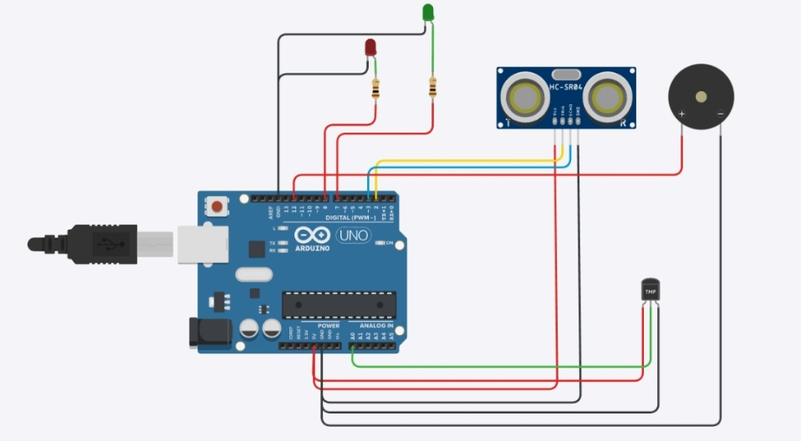
int redBulb = 8;
int greenBulb = 7;
int echo = 3;
int trigger = 2;
int buzzer = 12;

void setup(){
Serial.begin(9600);
pinMode(buzzer, OUTPUT);
pinMode(greenBulb, OUTPUT);
pinMode(redBulb, OUTPUT);
pinMode(trigger, OUTPUT);
pinMode(echo, INPUT);
}

void loop(){
double avalue = analogRead(A0);
double temperature = (((avalue/1024)*5)-0.5)*100;

digitalWrite(trigger, LOW);
digitalWrite(trigger, HIGH);
delayMicroseconds(10);
digitalWrite(trigger, LOW);
float duration = pulseIn(echo, HIGH);
float distance = (duration * 0.0343)/2;

if(temperature > 50){
digitalWrite(greenBulb, LOW);
digitalWrite(redBulb, HIGH);
}
else{
digitalWrite(greenBulb, HIGH);
digitalWrite(redBulb, LOW);
}

if(distance < 150)
digitalWrite(buzzer, HIGH);
else
digitalWrite(buzzer, LOW);
}

